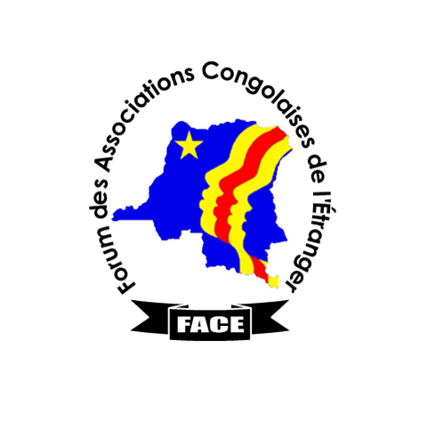

PRESS RELEASE

Sit-in for the restoration of lasting peace in the DRC.

The "Peace for Congo Network (Italy)» mobilized around John Mpaliza, a young Congolese who made ​​a march of 1600 km between Italy and Brussels in September 2012 to educate the world about the plight faced by the Congolese people has initiated in collaboration with the Forum of Congolese Associations Abroad "FACE" to which it belongs, a "sit-in" on Tuesday, March 5, from 11 am to 1 pm at the Round-Point Schuman, to claim the restoration of a lasting peace in the DRC.

This restoration of lasting peace in the DRC is impossible without justice.

Since 1998, the DRC has repeatedly been attacked by two neighboring countries through rebellions they create and orchestrate, in military supplies, weapons and ammunition, and finance. These countries have never been formally condemned by the UN nor vehemently sanctioned, despite war crimes and imprescriptible crimes against humanity arising from these rebellions.

Even being out of its torpor, following the capture of Goma by the M23, to finally acknowledge the problem, the UN secretary general did not dare explicitly mention the two aggressor countries, merely just mentionning a anonymous external support to the rebels. However, these attacks have generated repetitive desecration of the bodies of Congolese women, forced recruitment of child soldiers and the displacement of thousands of families, the massacre of defenseless civilians and looting of natural resources.

Therefore « the Peace for Congo Network » and FACE deplore the fact that the framework agreement for peace, security and cooperation in the DRC and the region signed on the UN initiative Sunday, February 24 in Addis Ababa has obscured the responsibilities of the crimes committed in the DRC by silencing the recurrent attacks suffered by the DRC and the names of the aggressor countries, while genocidairs are amnestied, despite overwhelming evidence, statements by UN experts, crimes against humanity committed during these attacks, a situation that denies justice to the Congolese pérénise impunity.

Thus, as European citizens FACE members, we believe that a radical change of attitude of the European Union vis-à-vis the attackers can positively affect the course of events. So we are launching an appeal to members of the Congolese diaspora and supportive friends of the Congolese people to come many and together to require he European Union, to take responsibility of stopping the war of plunder in DRC, impunity for war crimes and crimes against humanity, femicide, the killing of civilians, forced displacement of families and the recruitment of child soldiers.

At the end of the sit-in, a delegation will be received by the office of Ms. Catherine Ashton, Vice-President of the European Unon, for the submission of signatures on a petition.

Done at Brussels, 25 February 2013.

For "Peace for Congo Network » and « FACE »

Contacts : Nicole Emany phone : +32485254303 email:emanycole@yahoo.fr
Béatrice Léonard Lomami : phone : +32489689084 email : mediconsults@yahoo.fr

